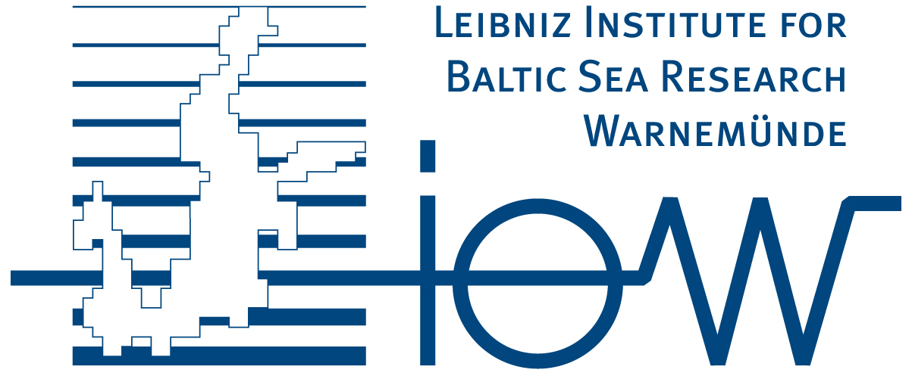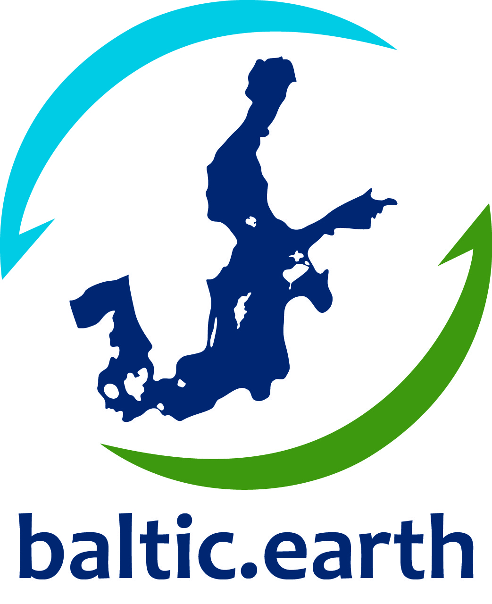
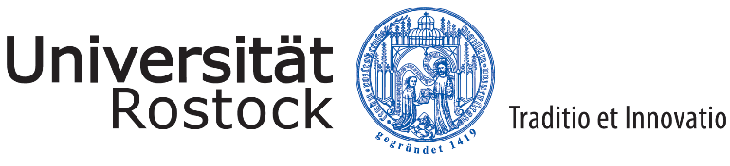
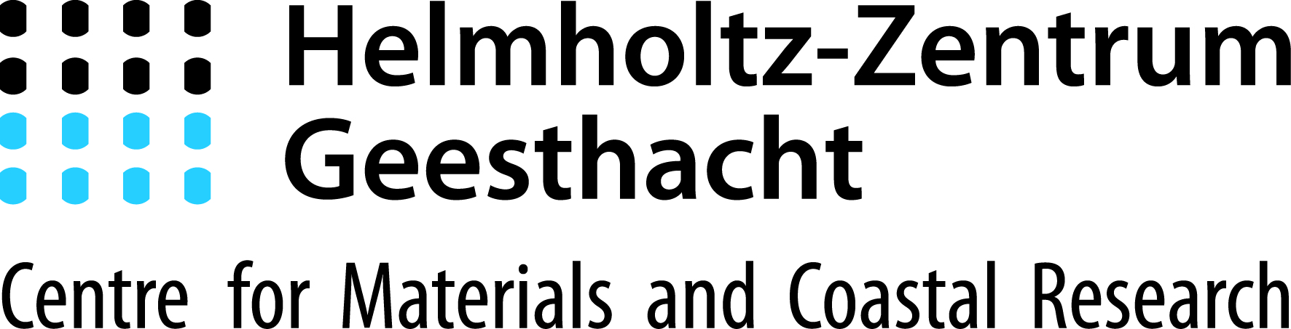

6th International Summer School on

“Climate of the Baltic Sea Region”
24 – 31 August 2020

co-organized by
Leibniz Institute for Baltic Sea Research Warnemünde (IOW), University of Rostock and
International Baltic Earth Secretariat at Helmholtz-Zentrum Geesthacht
under the umbrella of Baltic Earth (baltic.earth)
Draft Agenda

Day | Mon 24/8 | Tue 25/8 | Wed 26/8 | Thu 27/8 | Fri 28/8 | Sat 29/8 | Sun 30/8 | Mon 31/8
General topic | Course introduction; Basics of climate | Physical oceanography of the Baltic Sea; Student presentations | Physical oceanography of the Baltic Sea; Wave dynamics; Air-sea interaction | Climate variability of coastal seas; Eutrophication | Remote sensing; Hypoxia; Science communication | Climate modeling; Baltic Earth activities | Carbon cycle ; History of the Baltic Sea | Biological oceanography
Speaker/title  Morning session  09:00-10:30  (2 x 45 min) | Markus Meier: Course introduction and basics of climate dynamics | Short student presentations of their thesis work (3 min, each) | Markus Meier: Physical Oceanography of the Baltic Sea and other regional seas, part III | Markus Meier: Past and future climate variability of the Baltic Sea and other regional sea | Susanne Kratzer: Optical properties of Baltic Sea | Markus Meier: Climate Modeling – The global and regional perspective, part I | Karol Kulinski: Carbon cycle I | Marcus Reckermann: Biological Oceanography of the Baltic Sea
Break 10:30-11:00
11:00-12:30  (2 x 45 min) | Markus Meier: Climate state and global circulation patterns in the atmosphere | Markus Meier: Physical Oceanography of the Baltic Sea and other regional seas, part I | Laura Tuomi: Ocean surface waves | Christoph Humborg: Processes in the Baltic Sea catchment area I | Susanne Kratzer: Ocean Color Remote Sensing | Markus Meier: Climate Modeling – The global and regional perspective, part II | Karol Kulinski: Carbon cycle II | Examination  (45 minutes)
Lunch break 12:30-14:00
Speaker/title  Afternoon session:  14:00-15:30  (2 x 45 min) | Introduction in Jupyter notebooks (Jan) and R (Manja)  (Jan Kaiser, Manja Placke, Hagen Radtke, and Markus Meier) | Time series analysis I (Hagen)  (Hagen Radtke, Jan Kaiser, Manja Placke and Markus Meier) | Working with NetCDF data (Manja)  Exercises physical ozeanography (Markus)  (Hagen Radtke, Jan Kaiser, Manja Placke and Markus Meier) | Calculating air-sea exchange and sensitivity analysis (Jan)  “Montagsmaler” (Jan)  (Hagen Radtke, Jan Kaiser, Manja Placke and Markus Meier) | Daniel Conley: Hypoxia | Time series analysis II (Hagen)  Climate exercises (Markus)  (Hagen Radtke and Markus Meier) | Exercises waves and ARGO float data (Laura)  Repetition (Markus)  (Laura Tuomi and Markus Meier) | Students’ group presentations
Break 15:30-16:00
16:00-17:30  (2 x 45 min) | Markus Meier: Analysis of climate data | Markus Meier: Physical Oceanography of the Baltic Sea and part II | Laura Tuomi: Ocean surface layer dynamics | Christoph Humborg: Processes in the Baltic Sea catchment area II | Daniel Conley: Science communication | Marcus Reckermann: Baltic Earth –regional Earth system science and How to give a bad presentation | Markus Meier: History of the Baltic Sea | Students’ group presentations; resumé of the school

Lectures |  | Hours | Contents
Prof. Markus Meier |  | 22 | Physical Oceanography and Meteorology
 | Prof. Christoph Humborg | 4 | Terrestrial biogeochemistry
 | Dr. Karol Kulinski | 4 | Carbon cycle
 | Prof. Daniel Conley | 4 | Marine biogeochemistry and eutrophication
 | Dr. Laura Tuomi | 4 | Physical Oceanography
 | Prof. Susanne Kratzer | 4 | Remote sensing
 | Dr. Marcus Reckermann | 4 | Earth system science
Total |  | 46

Seminar | Hours | Contents
Prof. Markus Meier | 6 | Students’ presentations supervised by Markus Meier and Marcus Reckermann and NN

Exercises and tutorials | Hours | Contents
Prof. Markus Meier | 12 | Exercises, tutorials, and students group work supervised by Markus Meier, Jan Kaiser, Manja Placke, Hagen Radtke and LauraTuomi

